TITLE OF CONVR CONFERENCE PAPER (STYLE HEADING 1)
Author A & Author B
Affiliation 1 (e.g. National Taiwan University, Taiwan)
Author C
Affiliation 2
ABSTRACT: The abstract should be about 250-300 words in Normal Style, italic. A conference article header is built of the following parts: 1) The article title must be in uppercase, 14pt bold and must fit on a maximum of two lines and formatted as heading 1 style; 2) A list of authors in 10pt author style with author's first name, middle name initial and last name in the first line, and institutional affiliation on the second line with 10pt italic; and 3) Abstract lead by a bold and uppercase word "ABSTRACT:" in 10pt italic.
KEYWORDS: Following the bold, uppercase word "KEYWORDS:" on the same line are up to 7 keywords describing the article in 10pt italic keywords style.

PRINCIPLES (FIRST LEVEL HEADINGS: STYLE HEADING 2)
These instructions are intended to guide authors when preparing the abstract for 12th International Conference on Construction Applications of Virtual Reality (ConVR2012). Authors are requested to strictly adhere to the format specified in this template including the page size and margins. The best results are achieved if authors would overwrite the texts in this template file with their own. Any text copied from other documents must be pasted as “unformatted text” using the “Paste Special” menu command in Microsoft Word.
The default font is Times or Times New Roman in 10pt size. Paragraphs should be flushed left, with space between paragraphs. This template file sets the space automatically. (It works in MS-Word). Bold style is used in all titles, not to be used for emphasized words within the paragraphs. Italic should be used instead.
Articles must be formatted in such way that they can be printed on A4 paper (297 x 210 mm). Margins are all 25 mm. Text must be set in a single column. The header and footer area is set at a margin of 12mm. Please do not use the header and footer area. The full paper should be limited at a maximum of 12 pages.

FIRST LEVEL HEADINGS: STYLE HEADING 2
Headings are automatically numbered when the appropriate style is applied. The first level heading uses the style “Heading 2”. The second level heading uses the style “Heading 3” and so on. To achieve the correct style either select the appropriate style and then write the text or highlight existing text and then apply the required style.
First level heading are 12 point upper case Times New Roman, beginning at the left-hand margin (the same as the heading of this section). Use consecutive whole numbers with no full stops.

Second level headings: Style Heading 3
Second level headings are in 12 point Times New Roman, beginning at the left-hand margin. They are consecutively (and automatically) numbered after the preceding first order heading.

Third level headings: Style heading 4
These headings are typeset in 10 pt Times New Roman, beginning at the left-hand margin. They are consecutively (and automatically) numbered after the preceding second order heading. It is advisable to use this level of heading very sparingly.

Table 1: Tables must have a table caption on top of the table, followed by table lines and columns. Tables must have horizontal lines only. Text in tables must be 8pt or bigger.
 | Jan. | Feb. | Mar. | Apr. | May | Jun. | Jul. | Aug. | Sep. | Oct. | Nov. | Dec.
Sendai Average Temperature | 0 | 1 | 4 | 9 | 14 | 18 | 22 | 24 | 20 | 14 | 8 | 3
Ave. Minimum Temperature | -4 | -4 | -1 | 4 | 9 | 14 | 19 | 20 | 16 | 9 | 3 | -1
Ave. Maximum Temperature | 4 | 5 | 8 | 14 | 19 | 22 | 25 | 27 | 24 | 19 | 13 | 7

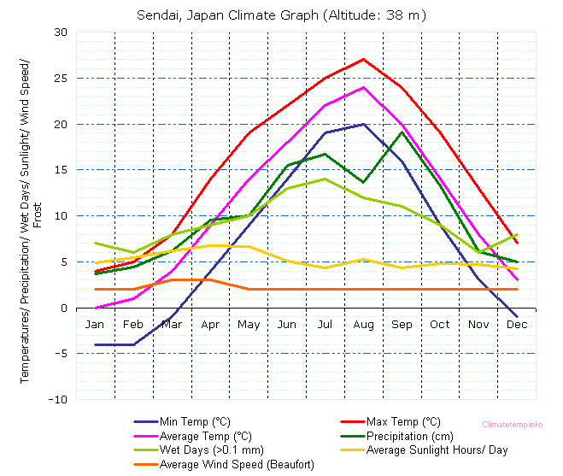
Fig. 1: Use of figures and graphics is encouraged. So is the use of color but make sure that they print well on black and white printers. If possible, the figures should be in a vector format. Figure captions are placed below the actual graphic. We suggest short captions (one line) and a detailed discussion of the figure in the text.

REFERENCES (STYLE HEADING 2)
References must be sorted alphabetically in the section "References". Modified Harvard style of referencing must be used. For example:
Jones A. S. (1994a). The future of electronic publishing, Journal of modern communications, Vol. 3, No. 5, 213-232.
Smith A. S. and Jones A. B. (1994). Published electronically, Proceedings of 4th international conference of office systems (Jones A. B., editor), University of New Brunswick, 213-232.

